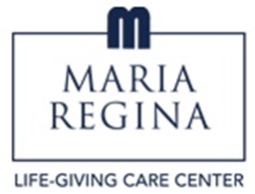
1725 Brentwood Road
Building 1
Brentwood, NY 11717-5589
Phone 631-299-3000
Fax 631-952-2378

3/31/23

Dear Visitor;

The New York State Department of Health has indicated that visitors to Nursing Homes will no longer be required to be tested for COVID. Effective 3/31/23, you will no longer be required to show proof of testing. However, you will continue to screen at the kiosk and obtain a visitor badge.

If you wish to take a test, we will continue to provide you with a test. The core principles of infection prevention still apply.

Please continue to wear a mask when visiting and practice good hand hygiene. If you are not feeling well or have been exposed to someone with COVID, we ask that you postpone your visit. While we are seeing the rates of COVID declining, we still want to maintain precautions.

We continue to appreciate your cooperation with our safety measures over these many months. We are looking forward to resuming a more normal routine going forward. The safety of our residents, staff and visitors is of upmost importance to us. We will continue to update you on changes as we enter a new season.

Thank you all so very much. As always, please let us know if you have questions or concerns.

Brenda Burton
Administrator

